Synopsis

End-to-End Machine Learning Classification System for Loan Default Prediction

Problem Id:2

Student Name: Anirudh Rana
Class Roll Number: 32
University Roll number: 2028641
Section and Group: U,G1

Student Name: Abhishek Negi
Class Roll Number: 3
University Roll Number: 2028377
Section and Group: U,G1

Student Name: Rahul Rawat
Class Roll Number:19
University Roll Number: 2028470
Section and Group: U,G1

- Problem Description:
The project addresses the critical challenge in the banking sector of identifying customers likely to default on loans. By analyzing historical banking data, the system aims to automate risk assessment, helping financial institutions minimize losses and make informed lending decisions. In real life, such systems ensure economic stability by preventing high-risk debt accumulation and allowing banks to offer better rates to reliable borrowers.

- Steps of Implementation:
The project will follow a structured Machine Learning pipeline as illustrated in the sample architecture:
- Data Collection: Gathering customer banking data, including credit history and demographics.
- Data Preprocessing: Cleaning data, handling missing values, and performing normalization. This phase includes Principal Component Analysis (PCA) for dimensionality reduction.
- Model Selection: Selecting Support Vector Machine (SVM) with various kernels (Linear, Polynomial, RBF) and K-Nearest Neighbors (K-NN).
- Training and Validation: Training the selected models on the processed dataset and tuning hyperparameters.
- Evaluation: Comparing model performance to identify the most accurate predictor.
- Final Model: Deploying the best-performing classifier for loan default prediction..
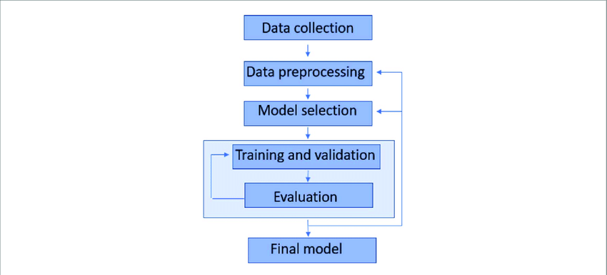
Fig. 1 Sample architecture

- Expected Modules/ Libraries to be used :
- Pandas: For data manipulation and analysis of tabular banking data.
- Scikit-learn: To implement SVM, K-NN, PCA, and evaluation metrics.
- Matplotlib/Seaborn: Used for Exploratory Data Analysis (EDA) and plotting results.
- NumPy: For efficient numerical computations and handling arrays.

- Expected Evaluation metrics and Plots to be used:
Precision and Recall: To measure the accuracy of positive default predictions and the ability to find all actual defaulters.
F1-Score: To provide a balanced harmonic mean between precision and recall.
ROC-AUC Curve: To visualize the trade-off between the true positive rate and false positive rate across different thresholds.
Confusion Matrix: To visualize the count of true positives, true negatives, false positives, and false negatives.

- Required topics from the subject:
- Data Preprocessing: Essential for transforming raw banking data into a format suitable for ML algorithms.
- Dimensionality Reduction (PCA): Used to simplify high-dimensional data while retaining essential features.
- Supervised Learning (SVM & K-NN): Core classification algorithms used to categorize customers based on risk.

- Platform Required:
Visual studio/ jupyter notebook/ python idle.

- Books and Link Sources:
Books and Link Sources:
- Hands-On Machine Learning with Scikit-Learn, Keras, and TensorFlow by Aurélien Géron.
- Introduction to Machine Learning with Python by Andreas Müller.
- Scikit-learn Official Documentation (Classification section).
- UCI Machine Learning Repository (for banking datasets).

